A
Lab Records of
Programming with Problem Solving Lab
Bachelor of Computer Application -I Sem


RUNGTA INTERNATIONAL SKILLS UNIVERSITY
SESSION: 2025-26

Submitted By: -
Kavita Kanwar Samiksha Singh
(Assistant Professor) REF/2025/03908

Submitted To:

RUNGTA INTERNATIONAL SKILLS UNIVERSITY, CG
SCHOOL OF INFORMATION TECHNOLOGY

Index
Sno | Name of Practical | Submission Date | Remarks
1. | Write a program to check whether the year is a leap year or not
2. | Write a program to count the number of vowels in a string.
3. | Write a program to reverse a number.
4. | Write a program to find mean, median and mode of a given number.
5. | Write a Python program to reverse only the vowels in a given string, keeping other characters in their original positions.
6. | Create a script that takes an integer and displays its binary, octal, and hexadecimal representations neatly formatted.
7. | Given a list of items (possibly with duplicates), write a program that removes duplicates and displays the sorted list.
8. | Accept a list of students and their marks as tuples. Display the name of the student with the highest marks.
9. | Read data from a CSV file containing employee details (name, department, salary) and display the average salary by department.

Practical-1
Aim: Write a program to check whether the year is leap or not

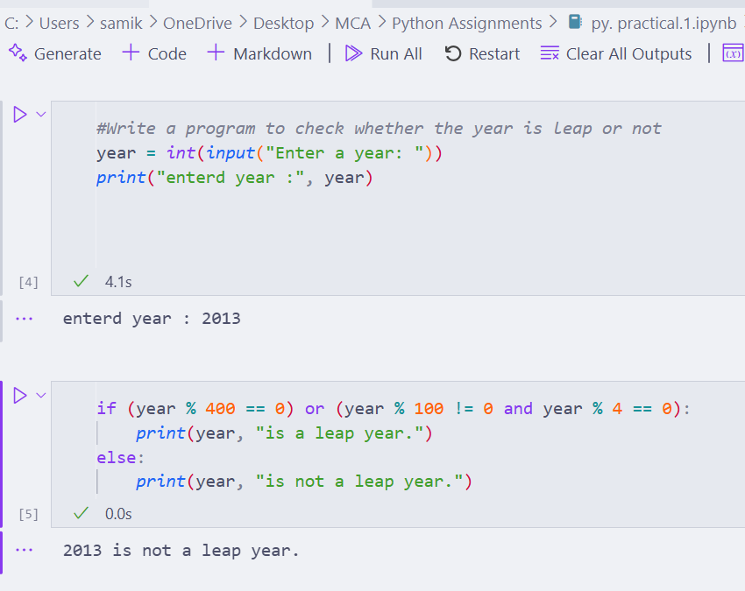
Practical-2
Aim: Write a program to count no. of vowels in a string.

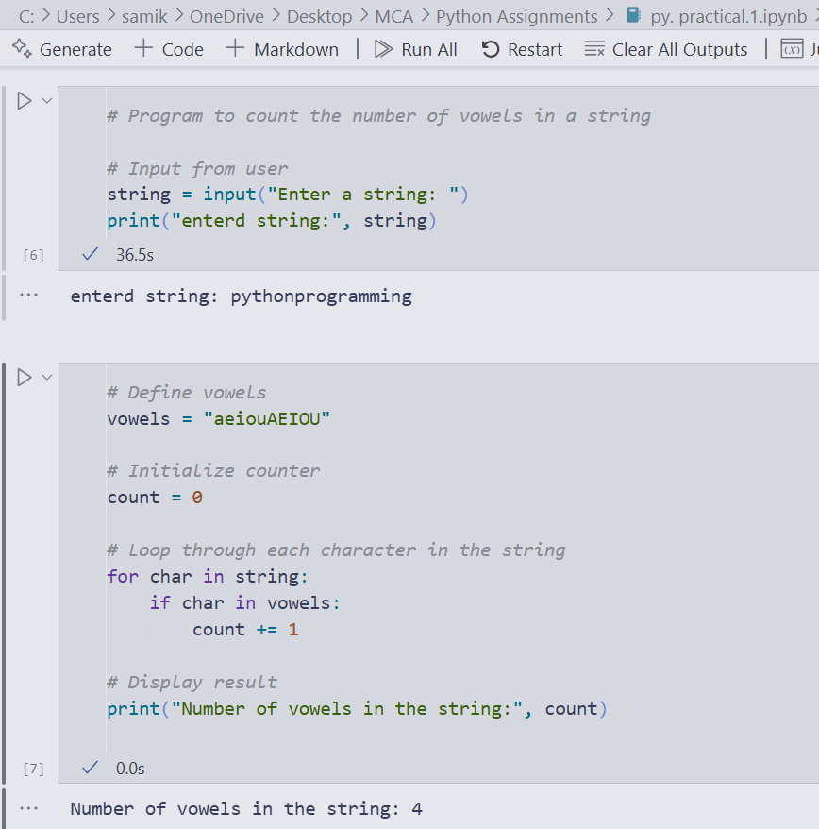
Practical-3
Aim: Write a program to reverse a number.
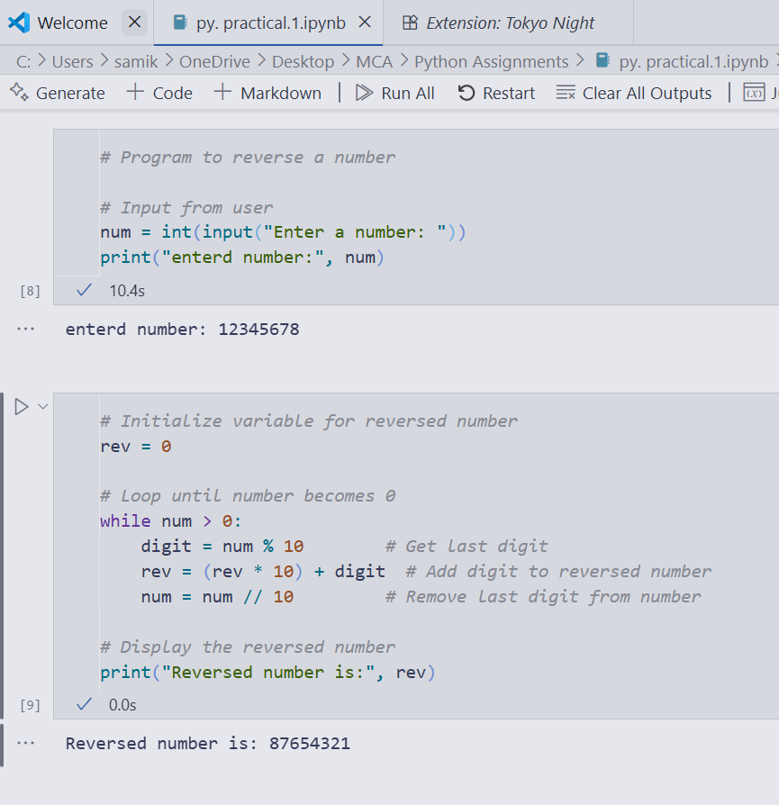

Practical-4
Aim: Write a program to find mean, median and mode of given number.

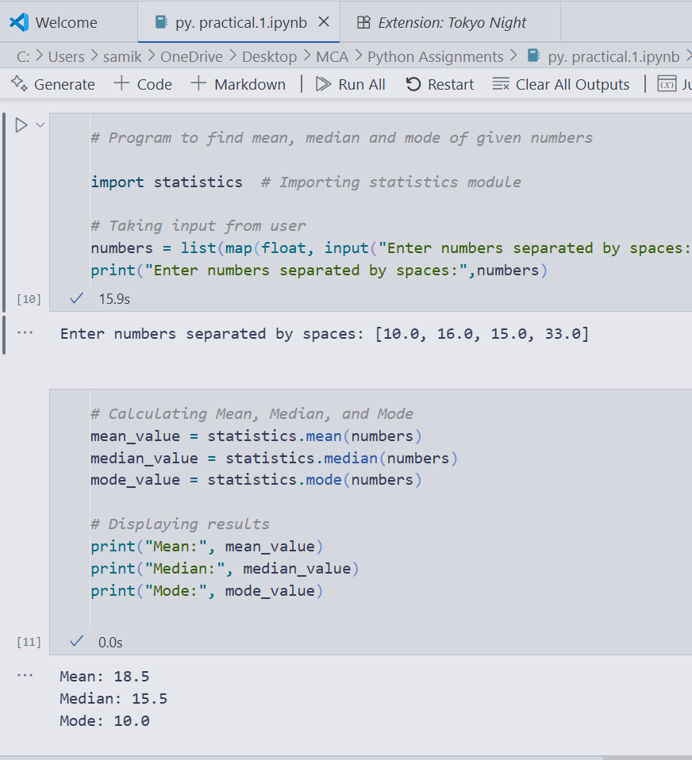

Practical – 5
Aim: Write a Python program to reverse only the vowels in a given string, keeping other characters in their original positions.

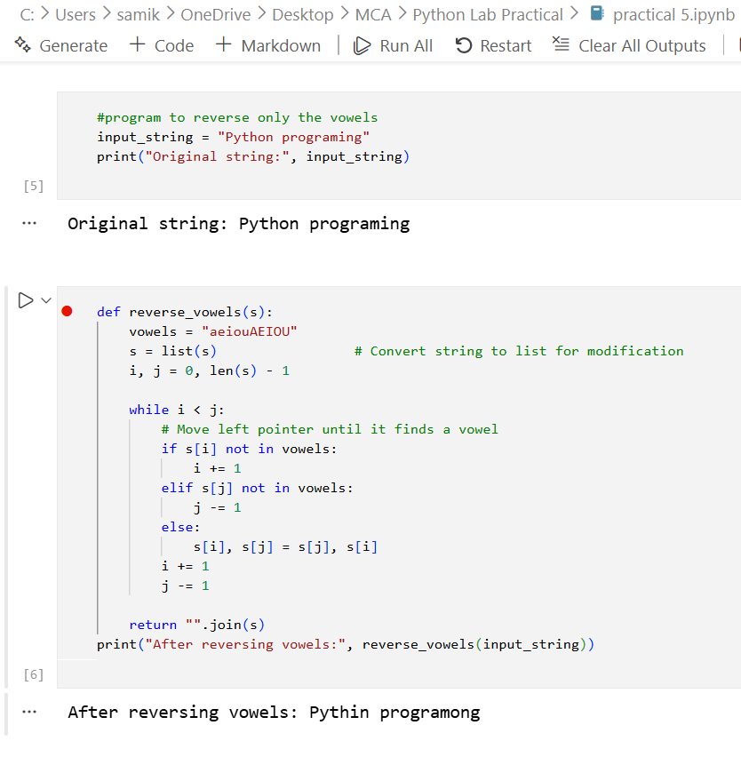
Practical – 6
Aim: Create a script that takes an integer and displays its binary, octal, and hexadecimal representations neatly formatted.

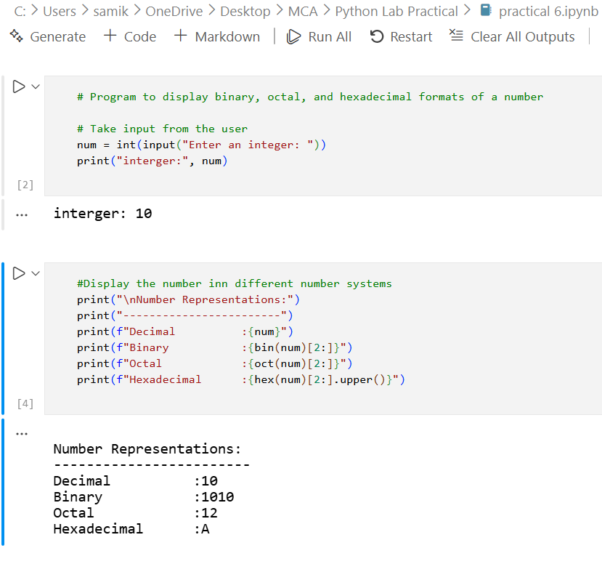
Practical – 7
Aim: Given a list of items (possibly with duplicates), write a program that removes duplicates and displays the sorted list.

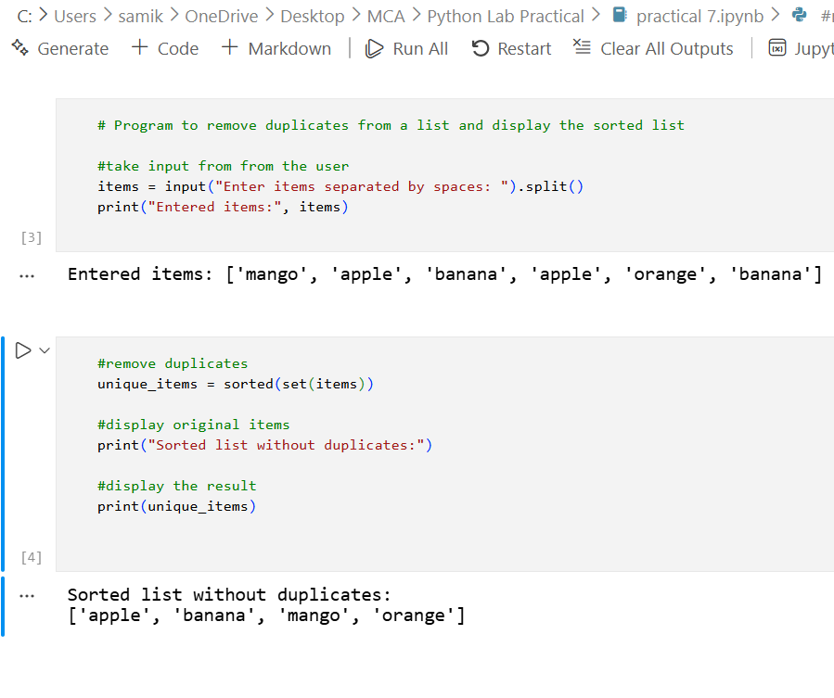
Practical – 8
Aim: Accept a list of students and their marks as tuples. Display the name of the student with the highest marks.
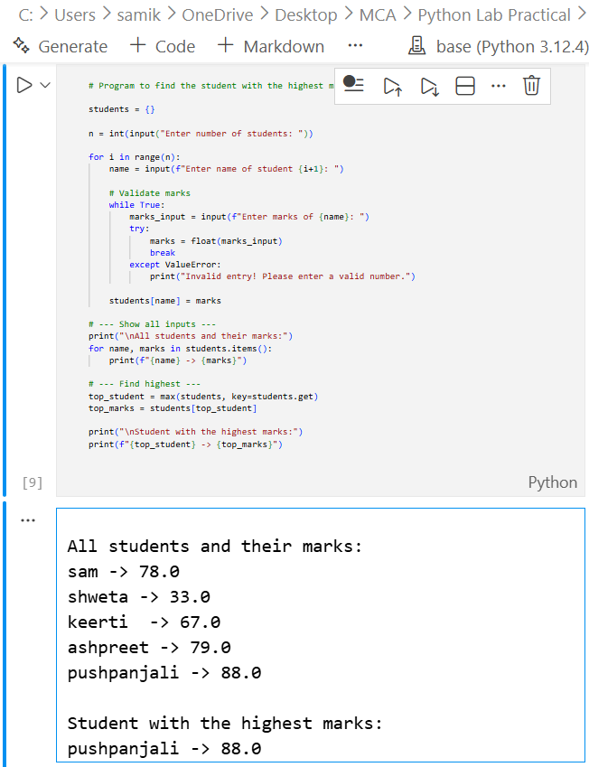

Practical – 9
Aim: Read data from a CSV file containing employee details (name, department, salary) and display the average salary by department.
Input (CSV):{(John,IT,50000),(Mary,IT,55000),(Alice,HR,48000),(Bob,HR,52000)} 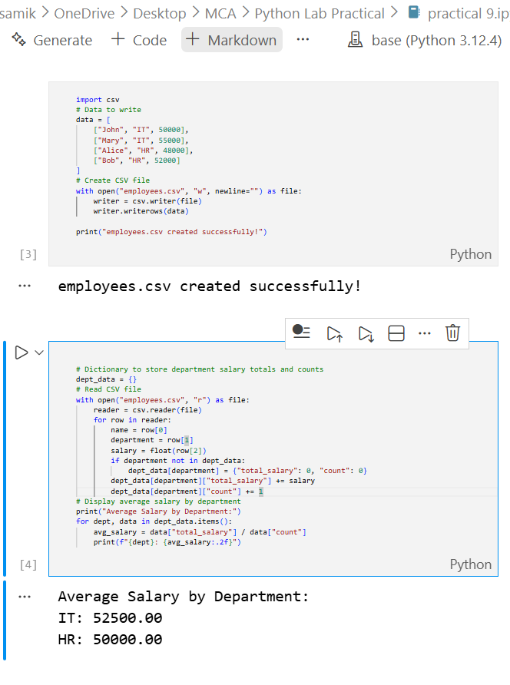
Practical 10

AIM- Write a Program to find following using math module

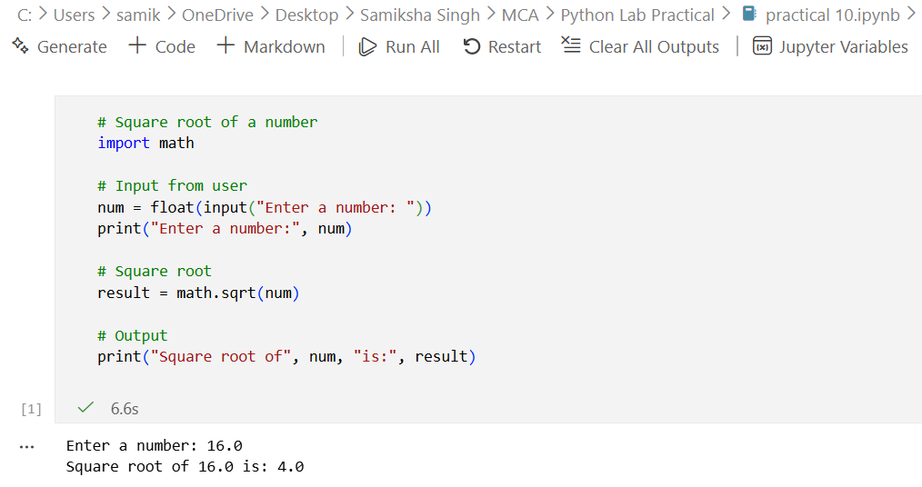
- Square Root of Number

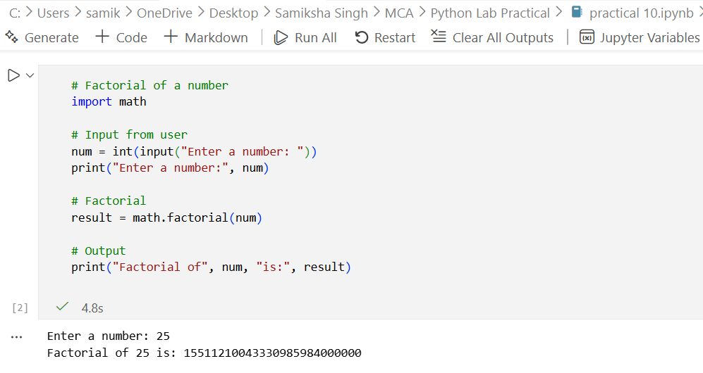
- Factorial of a number

- power of number
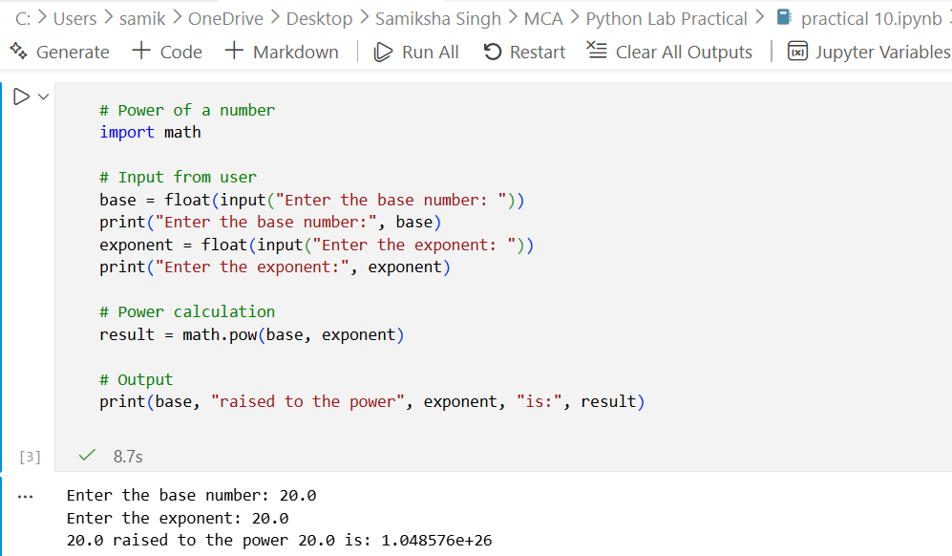
Practical 11

AIM- Write a Program to find area & circumference of a circle
(Take a input from a user)
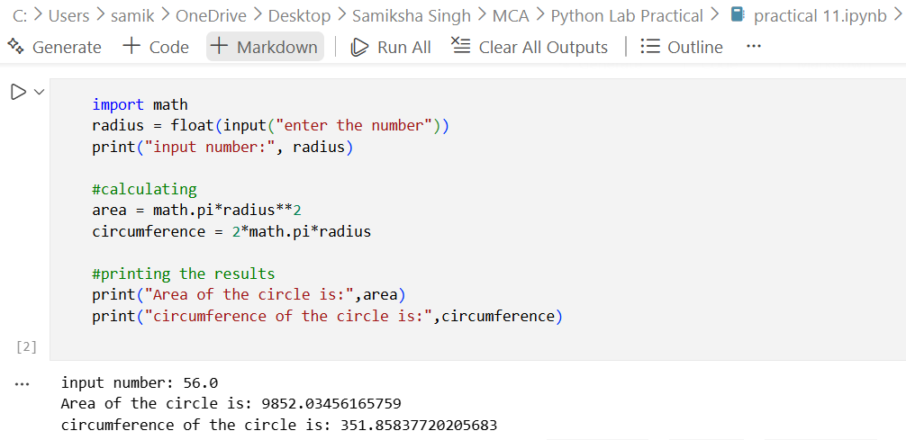

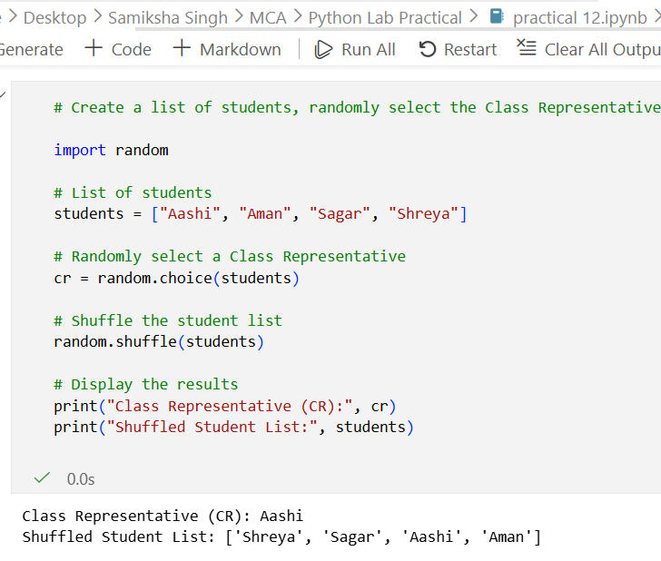
Practical 12
AIM-Create a list of a student from which randomly select the CR & shuffle the list.

Practical 13

AIM- Write a program to generate random password of 12 characters using UPPERCASE & lowercase alphabets, digits special characters (%, #, $, *, !)
start password with capital letter or digit.
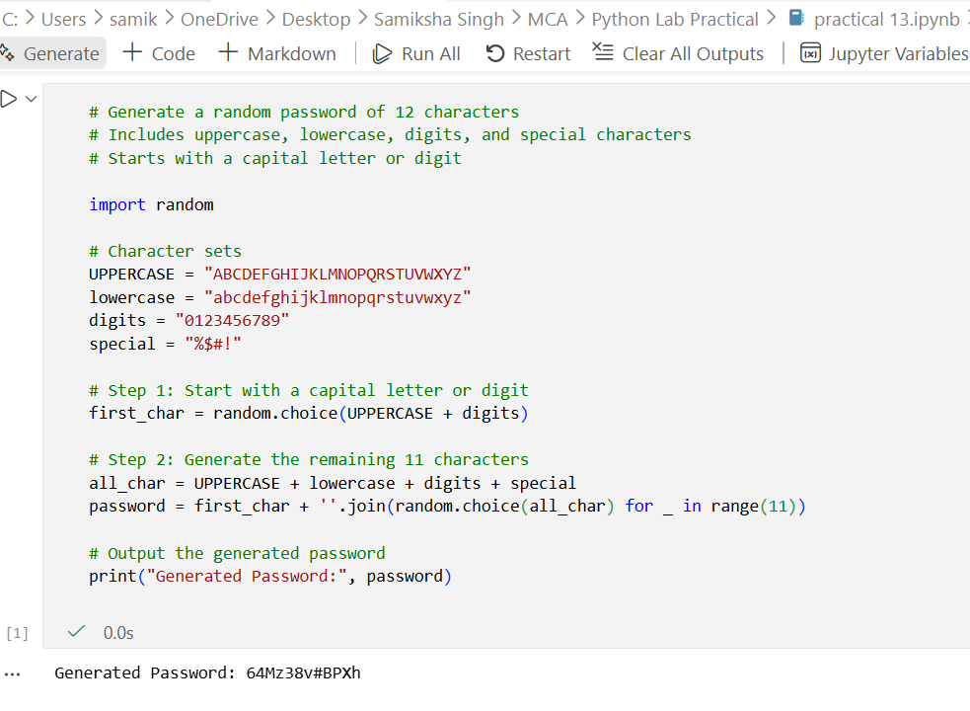

Practical 14
AIM- To create a Python package named shapes with modules to calculate the area and perimeter of circle and rectangle.

